Snohomish Radio Aero Club New Membership Application

NOTE: AMA & SRAC memberships (including flying privileges) expire annually on December 31st.
NOTE: Application for membership is not complete until AMA registration has been verified.
NOTE: Past or current SRAC members do NOT need to complete this form. See Payments.
NOTE: Ability level: New members will be listed as Training until verified by a flight instructor.
Payments: Attached to application OR paid through PayPal using link at https://www.sracinc.org/membership

------------------- Adult or Youth Applicant -----------------------
Membership Type | Club Dues | Field Use Fee | Total Paid
AMA Number Ability Level
First Name Last Name
Phone number Date of Birth
Email Note: Print email address CAREFULLY
Address
City Zip
Emergency Contact FN & LN (if different)
Phone number
“I have read and agree to comply with the AMA Safety Code and all SRAC field rules and safety regulations. I am aware that modeling may present hazards to participants and spectators. I exempt, waive, and relieve SRAC, its officers and field owners from all current or future liability for personal injury, property damage, or wrongful death.”

Signature Date

Membership Type  --- Partner OR Junior Applicant --- | Club Dues | Field Use Fee | Total Paid
AMA Number Ability Level
First Name Last Name
Phone number Date of Birth
Email Note: Print email address CAREFULLY
“I have read and agree to comply with the AMA Safety Code and all SRAC field rules and safety regulations. I am aware that modeling may present hazards to participants and spectators. I exempt, waive, and relieve SRAC, its officers and field owners from all current or future liability for personal injury, property damage, or wrongful death.”

Signature Date

President: David Pitkin 425-327-9458 Treasurer: Marty Menia 425-418-8692
New Members

Mail check made out to SRAC along with both pages to:
Marty Menia
11107 25TH ST NE
LAKE STEVENS, WA 98258-9130
Scan or photograph both pages.
Then email to: Marty Menia
SRAC501c3@gmail.com
Then pay via PayPal using
https://www.sracinc.org/newmembers1

OR

- NEW MEMBERS: Send this page AND the application to the address listed at the bottom of the application.
- Pay via PayPal (use links) OR Checks should be made out to SRAC inc. OR Snohomish Radio Aero Club.
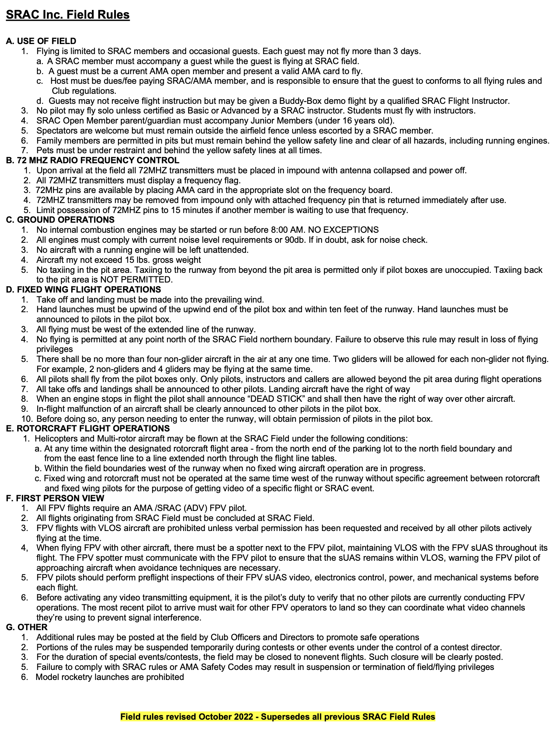
- Signature on page one verifies that you have read and agree to the following. Application will be kept on file. Future yearly applications will not be necessary.

